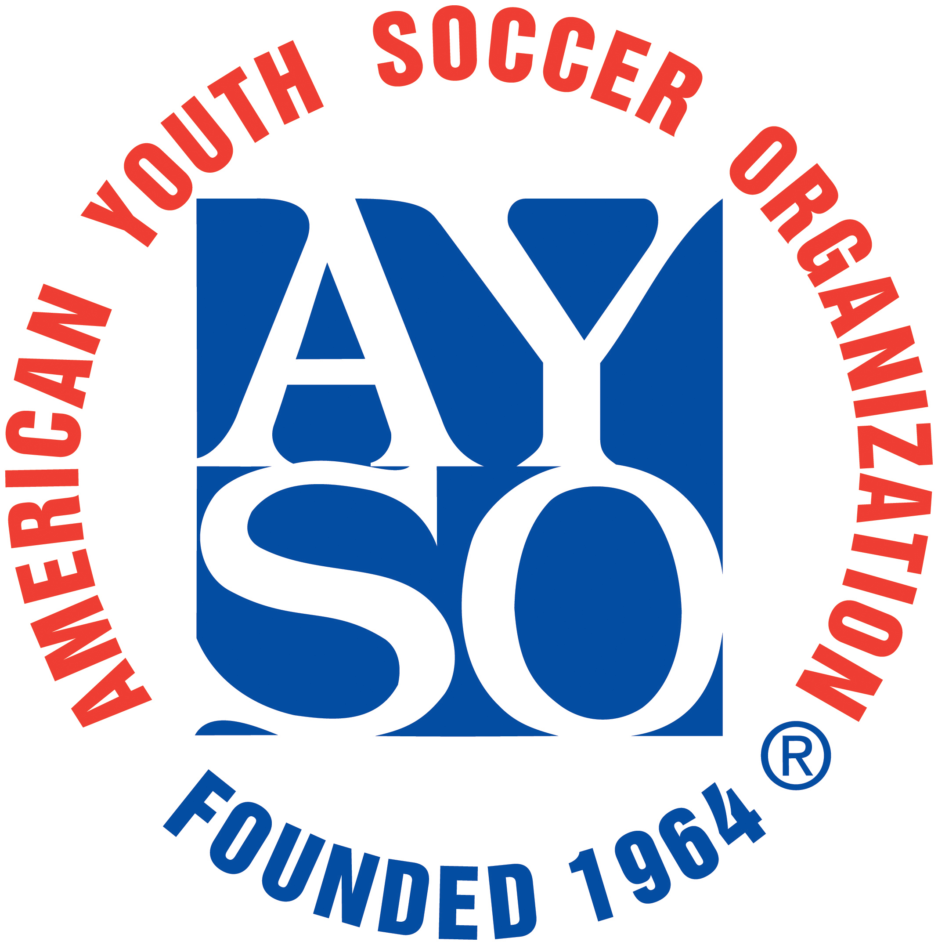
Region of the Year
2015

In recognition of the AYSO region which best represents the organization in its support of AYSO philosophies and policies, in it’s striving for constant improvement, and in its commitment to training volunteers,
REGION 6/D/418
ROBERT RANDOLPH

